STUDENT |  | GRADER | Total Score
 |  |  | Total Score
  I am submitting my own work, and I understand penalties will
  be assessed if I submit work for credit that is not my own.
   | Print Name |  | ID Number
   | Sign Name |  | Date
  # | Points | Score
  1 | 4
  2 | 8
  3 | 6
  4 | 12
  5 | 4
  6 | 10
  7 | 8
  8 | 6
  9 | 6
 |  |  | Weeks late
 |  |  | Adjusted Score
 |  |  | Adjusted Score
  Estimated Work Hours
  1 | 2 | 3 | 4 | 5 | 6 | 7 | 8 | 9 | 10
  1 | 2 | 3 | 4 | 5 | 6 | 7 | 8 | 9 | 10
  Overall Weight
Adjusted Score:
Deduct 20% from score for each week late

Problem 1. Sketch circuits for the following logic equations.

Y <= (A and B and C) or not ((A and not B and C and not D) or not (B or D));

X <= (A xor (B and C) xor not D) or (not (B xor C) and not (C or D))

Problem 2. Sketch circuits and write VHDL assignment statements for the following equations.

F = Σm(1, 2, 6) F = ΠM(0, 7)

Problem 3. Write logic assignment statements for the following circuit.

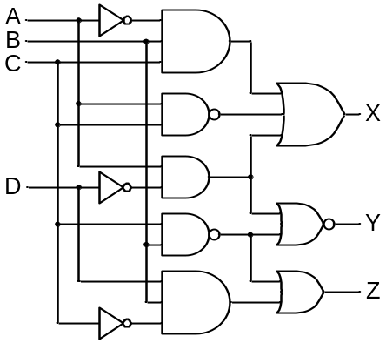

Problem 4: Sketch circuits and write VHDL assignment statements for the truth tables below.

A | B | C | F
0 | 0 | 0 | 1
0 | 0 | 1 | 0
0 | 1 | 0 | 1
0 | 1 | 1 | 0
1 | 0 | 0 | 1
1 | 0 | 1 | 1
1 | 1 | 0 | 1
1 | 1 | 1 | 1

A | B | C | F
0 | 0 | 0 | 1
0 | 0 | 1 | 1
0 | 1 | 0 | 0
0 | 1 | 1 | 0
1 | 0 | 0 | 0
1 | 0 | 1 | 0
1 | 1 | 0 | 1
1 | 1 | 1 | 1

A | B | C | F
0 | 0 | 0 | 1
0 | 0 | 1 | 0
0 | 1 | 0 | 0
0 | 1 | 1 | 1
1 | 0 | 0 | 1
1 | 0 | 1 | 0
1 | 1 | 0 | 0
1 | 1 | 1 | 1

Problem 5: Sketch POS circuits for the 2XOR and 2XNOR functions.

Problem 6: Sketch the circuit described by the netlist shown, and complete the timing diagram for the stimulus shown to document the circuit’s response to the example stimulus. Use a 100ns vertical grid in your timing diagram, and show all inputs and outputs.

G1: INV(sel,net1)

G2: NAND2(net1,a,net2)
G3: NAND2(sel,b,net3)
G4: NAND2(net2,net3,y)

Netlist

Force a,b,sel to ‘0’

simulate 100ns

Force a to ‘1’

simulate 100ns
Force sel to ‘1’
simulate 100ns

Force b to ‘1’
Simulate 100ns
Stimulus

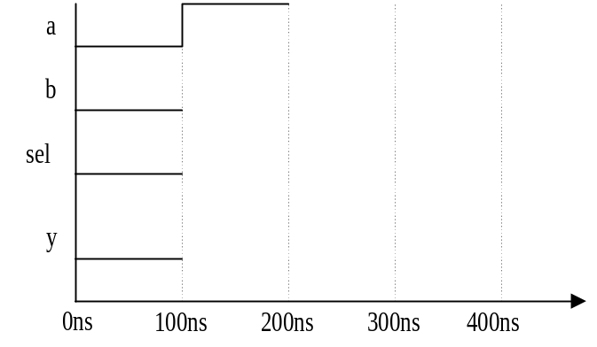
Timing diagram showing input/output changes over time

Problem 7: Create a truth table that corresponds to the simulation shown below. Show all input and output values in the truth table, and sketch a logic circuit that could have been used to create the waveform.

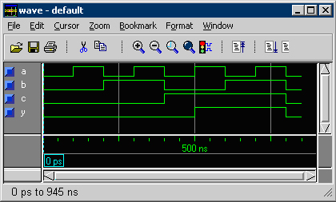
A | B | C | Y
0 | 0 | 0
0 | 0 | 1
0 | 1 | 0
0 | 1 | 1
1 | 0 | 0
1 | 0 | 1
1 | 1 | 0
1 | 1 | 1

Problem 8. The Seattle Mariners haven’t had a stolen base in 6 months, and the manager decided it was because the other teams were reading his signals to the base runners. He came up with a new set of signals (pulling on his EAR, lifting one LEG, patting the top of his HEAD, and BOWing) to indicate when runners should attempt to steal a base. A runner should STEAL a base if and only if the manager pulls his EAR and BOWs while patting his HEAD, or if he lifts his LEG and pats his HEAD without BOWing, or anytime he pulls his EAR without lifting his LEG. Sketch a minimal circuit that could be used to indicate when a runner should steal a base.

Problem 9. A room has four doors and four light switches (one by each door). Sketch a circuit that allows the four switches to control the light – each switch should be able to turn the light on if it is currently off, and off if it is currently on. Note that it will not be possible to associate a given switch position with “light on” or “light off” – simply moving any switch should modify the light’s status.

